Login Page

1)

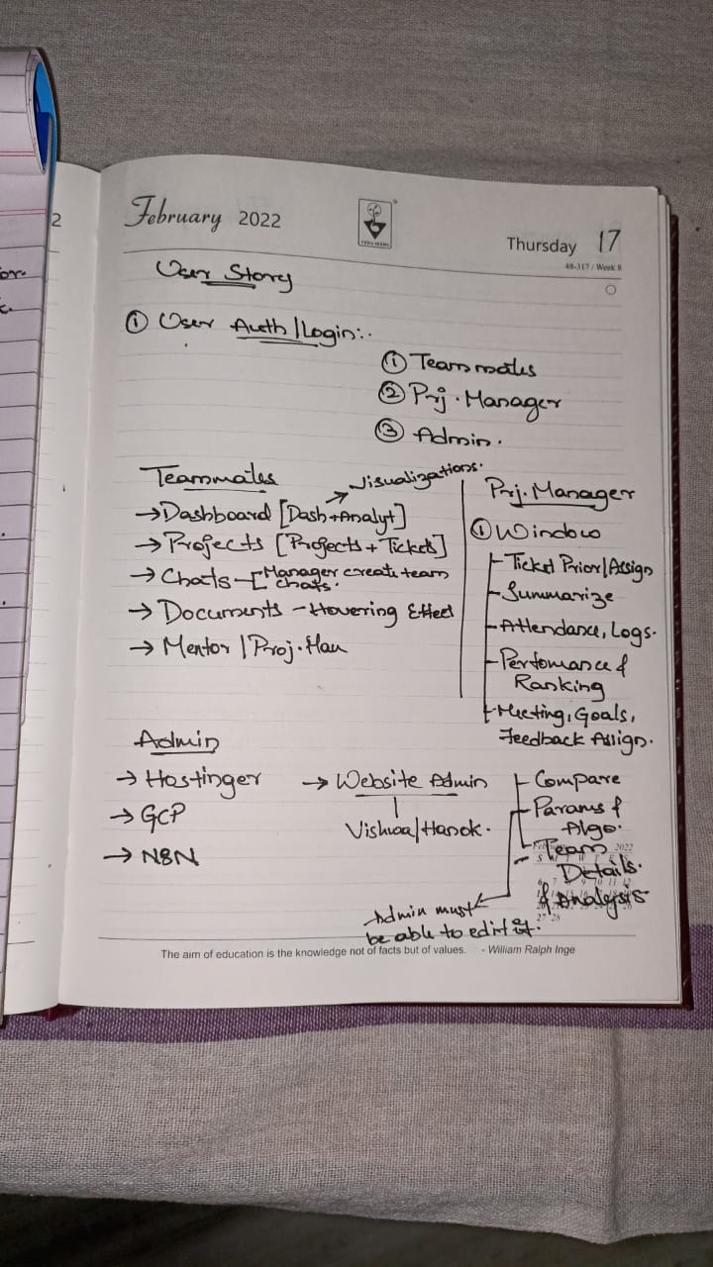

2)

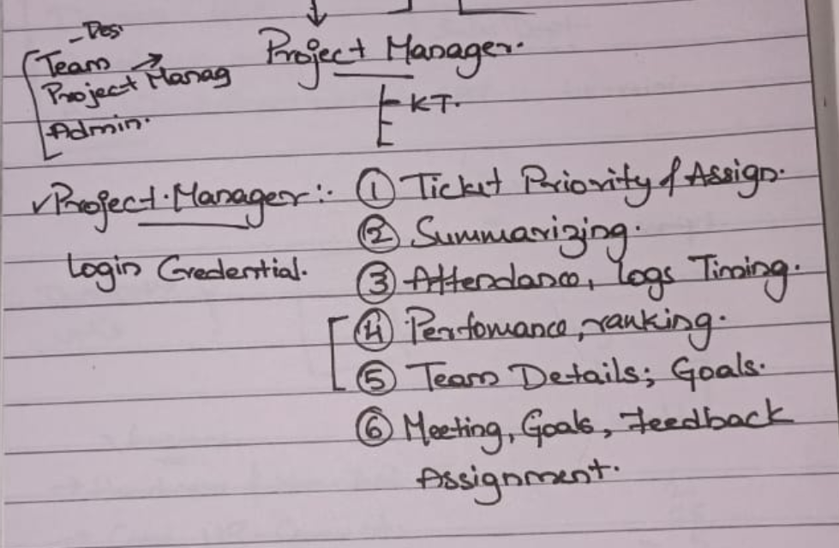

**Dashboard**

“ANALYTICS” window should be integrated into the Dashboard.

3) Should remove “Team Leaderboard”

4) In place of “Upcoming Tasks” in the Dashboard:

* First Include “In Progress” tasks
* And then once those tasks are finishing one by one, “To Do” tasks should appear from the bottom one by one. And only 3 tasks should appear in that card at a time.
* This card should be highlighted so that the students get focused quickly without getting confused.
* Change the name of the card to “Tasks”.

5) Button Animations

## **Neon Glow Button**

## A Neon Glow Button is having a neon colored border and shadow, which on being hovered gives a Neon Colored Background Colour making it stand out against a dark background.

## **Button with slide-in from bottom bg animation**

When you hover over this button, it displays a slide-in from the bottom as background color.It is a sleek and modern button design that incorporates smooth transitions and dynamic overlay effect, which enhances the overall user experience.

6) Visualisation of cards in the Darshboard

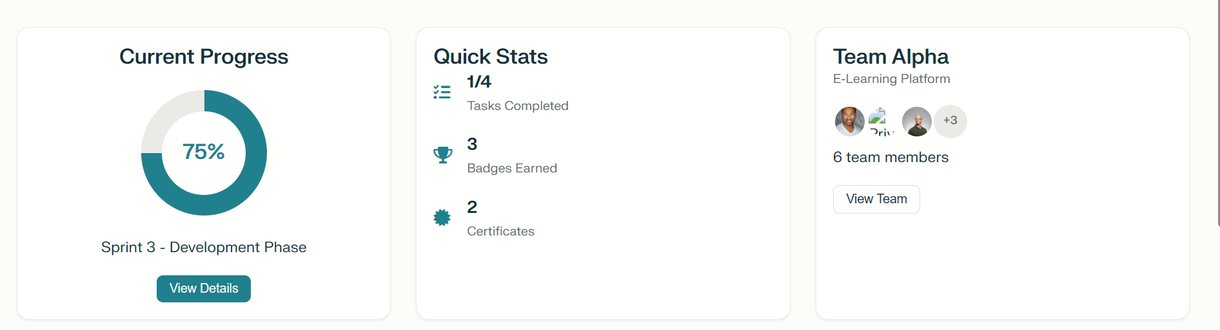

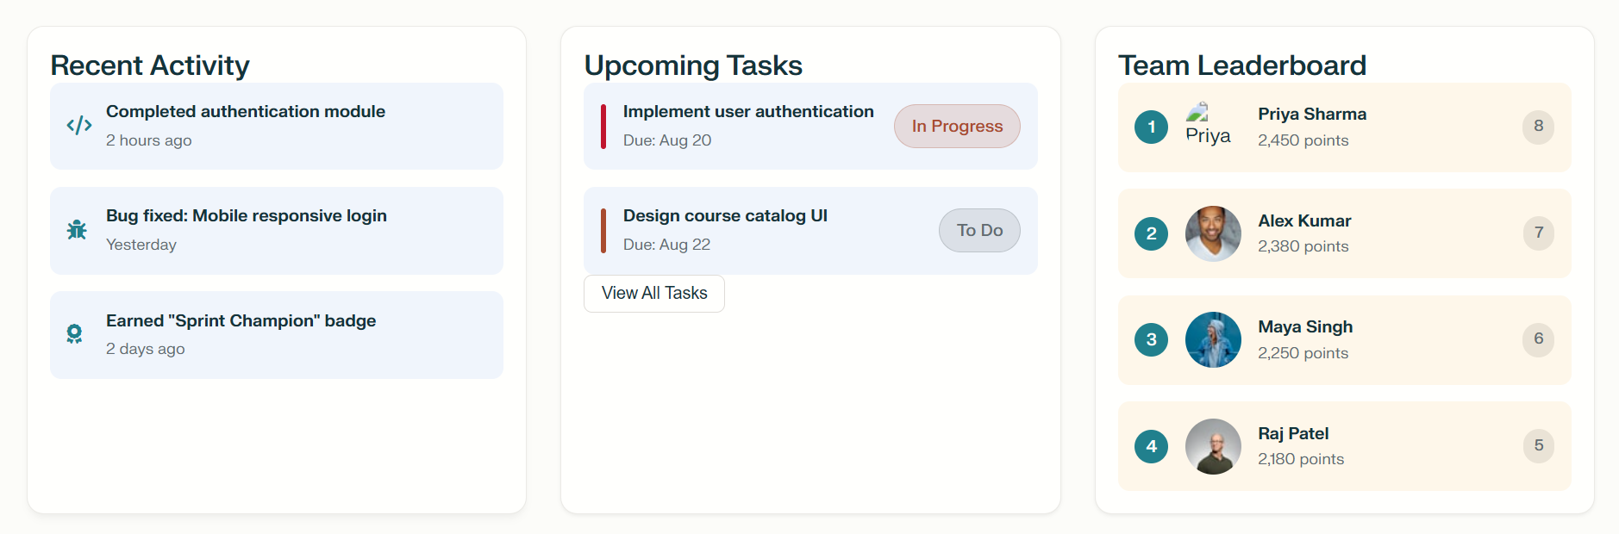

Like this the page/window should look spacious.

* Upcoming tasks card should be single and wide at the bottom because we are removing “Team Leaderboard”

**Projects**

7) Tasks that are in each section (To Do, In Progress, Review & Done) should update themselves according to their progress state.

8) “Ticket generation” should be included in this Window and the generated tickets should be automatically updated in the tasks list.

**Documents**

9) All “Edit and Export buttons” should be aligned in the same line.(For all cards)

10) Just like the “Document Template” card pop-up feature, cards with documents in the “Documentation Centre”.

**Mentorship/Project Manager**

11) Align the cards to the centre and keep some gap between the cards.  
12) Include MOM generation and summarisation Assistance for the Teammates and the Project Manager.

13) Give a “Push notification” animation for the notifications in the Project Manager window.  
14) Remove “Achievements and Badges” card.

**For Project Manager Login**

15) These should be in the main window for the Project Manager

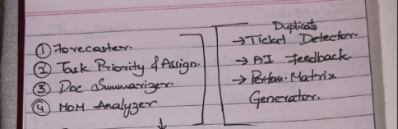

**For Admin Login**

16) 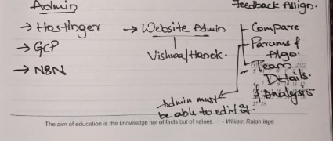

Only these are for admin.

*Note: In students and project managers window, try these animations  
<https://prismic.io/blog/css-hover-effects>  
In this website, try

### 1. Holographic card

### 8. Cursor animations

### 16. Social media icons hover effect

### 19. CSS social tiles(If Incorporable)

### 21. Creative menu hover effect

### 23. Magic line navbar